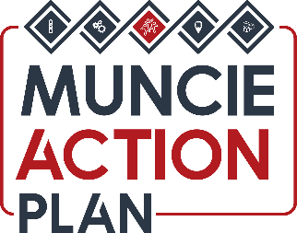

TASK FORCE 2 Beautification & Event

PROJECT FUND
Funded by the Zeigler Foundation

PROJECT FUND APPLICATION FORM

This project fund is intended to support beautification efforts led by neighborhood associations and costs related to community building events within the City of Muncie’s neighborhoods.

The Application Form must be submitted via email to Heather Williams at hlwilliams@bsu.edu.

In addition to the Application Form the following must be included as attachments to the same email:
- Neighborhood Association’s Articles of Organization or By-Laws
- Copies of the Neighborhood Association’s last two bank statements
- Names of Officers or Steering Committee Members along with all contact information (address, phone number, and email address)
- If this request is for equipment or services provide at least two quotes
*If for any reason the association cannot meet these requirements, please provide a detailed explanation in the application email.

- Name and contact information of the person in your neighborhood who will be responsible for the administration of and accounting for the funds:

- The name that the check should be made out to and the address that the check should be sent to:

- Did the neighborhood association vote for this project or purchase? Please provide evidence of this of this approval (meeting minutes, letter of support, etc.)

- Amount requested (not to exceed $200.00):

- Are you applying to any other organization for additional funding for this project?
- If yes, provide the source and amount of other funds that will be used for this project:

- Describe how the funds will be used:

- How will funding impact the neighborhood association?

- How will the project be measured and evaluated?

